Lab 7: Controlling Current with Op-Amps

ISIM Fall 2019

Lilo Heinrich

**Circuit**

This circuit is a current source, producing a current that relates to the voltage input. It has a maximum input voltage of 5V and a reference voltage of 2.5V which its’ measurements are centered on. I input a square wave of different amplitudes but with a fixed offset of 2.5V to characterize its response to different input voltages.

­­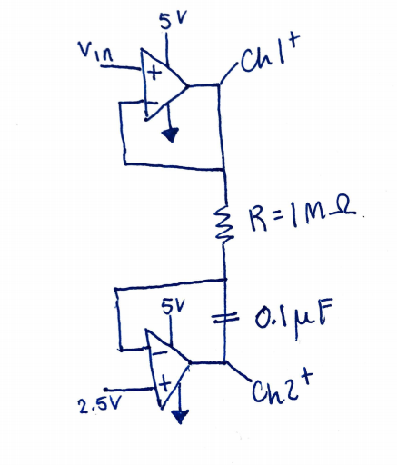

**Data Table**

dV/dt = Vin / (R*C) where R = 1 MΩ and C = 0.1 µF. Therefore RC = 0.1 sec^-1 and dV/dt = Vin*10.

|  |  |  |  |  |
| --- | --- | --- | --- | --- |
| Vin (V) | Reference Voltage (2.5V) - Vin | Theoretical = Vin * 10 (V/s) | dV/dt (V/s) | Percent Error |
| 0.5 | 2.0 | 20.0 | 19.0 | 5.0 |
| 1.0 | 1.5 | 15.0 | 14.3 | 4.7 |
| 1.5 | 1.0 | 10.0 | 9.6 | 4.0 |
| 2.0 | 0.5 | 5.0 | 4.7 | 6.0 |
| 3.0 | -0.5 | -5.0 | -5.1 | -2.0 |
| 3.5 | -1.0 | -10.0 | -10.0 | 0.0 |
| 4.0 | -1.5 | -15.0 | -14.7 | 2.0 |
| 4.5 | -2.0 | -20.0 | -19.3 | 3.5 |

**Interpretation**

Considering that the error percent is under 10% at all times and the general trend of the voltage relating to a consistent and proportional change in the linear slope of the voltage over time, it has been proven that this circuit is accurately characterized by the equations given in the lab handout, specifically that dV/dt = 𝝙Vcap / (R*C).